**NIIT UNIVERSITY DISCUSSION PORTAL**

**White Box Testing**

Members:

Utkarsh Srivastava, Shronit Bharagava, Yatham Praveen, Sourabh Kaushal, Siddhartha Kille

As the white box testing suggests here we create test cases keeping in mind the codes of the software and hence we created test cases and proceeded.

Since we are using C# as our backend the unit test cases are run on them using **NUnit**

Here test cases were created using selenium.

Below is the description of how the test cases were performed

* Selected the webpage(Here Login page) for which the test is to be performed
* Run that webpage on Mozilla Firefox with the extension of Selenium WebDriver
* The web extension creates a script for the test case, we take that test case on to visual studio where NUnit package was already setup and then we did run the test case through visual studio’s analyze and debug function

Rest test cases are in the same directory where this document is placed.

For some test cases we have given remarks:

Below is the description of how this was performed for login page:

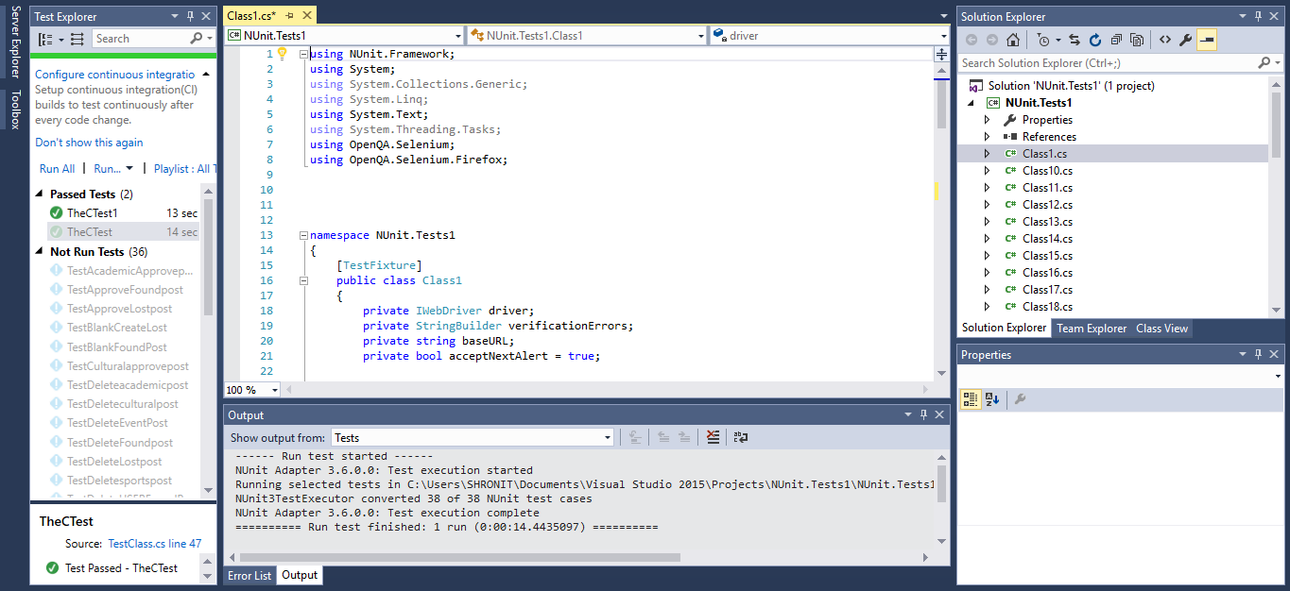The Snapshot of Visual studio while running the test case

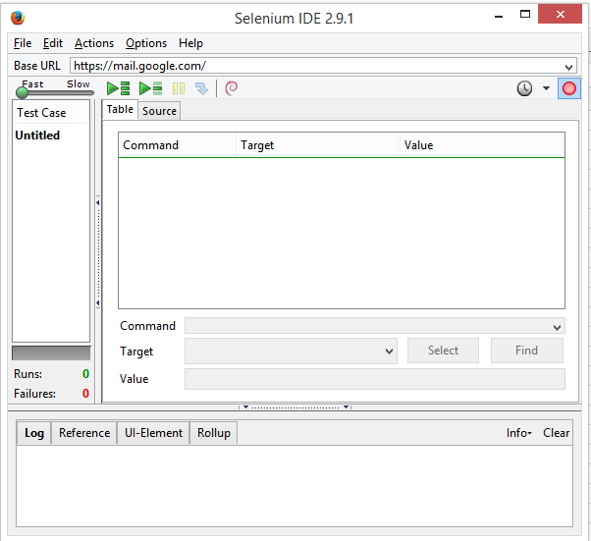

The output after analyzing and debugging were:

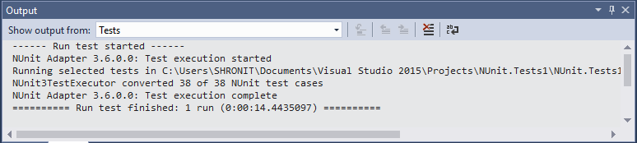

The Test result was

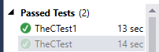

Hence for every functionality on various webpages we created separate test cases and run them on Nunit analyzer inside Visual Studio.

Below the result that came for after running the test cases on Nunit:

|  |  |  |  |
| --- | --- | --- | --- |
| **Testcase Name** | **Testcase Result** | **Timetaken** | Remarks(All Partially passed cases were tested seperately manually) |
| TheCTest | Sucessfully Passed | 13 sec |  |
| TheCTest1 | Sucessfully Passed | 14 sec |  |
| TheCTest2 | Sucessfully Passed | 14 sec |  |
| TheCTest3 | Sucessfully Passed | 14 sec |  |
| TestAcademicApprovepost | Sucessfully Passed | 14 sec |  |
| TestApprovefoundpost | Sucessfully Passed | 14 sec |  |
| TestBlankCreateLost | Successfully Passed | 25 sec |  |
| TestBlankfoundpLost | Successfully Passed | 25 sec |  |
| TestCulturalApprovepost | Successfully Passed | 25 sec |  |
| TestDeleteacademicpost | Sucessfully Passed | 24 sec |  |
| TestDeleteculturalpost | Sucessfully Passed | 22 sec |  |
| TestDeleteEventpost | Sucessfully Passed | 24 sec |  |
| TestDeleteFoundpost | Sucessfully Passed | 25 sec |  |
| TestDeleteLostpost | Sucessfully Passed | 22 sec |  |
| TestDeletesportspost | Sucessfully Passed | 22 sec |  |
| TestDeleteUSERFoundpost | Sucessfully Passed | 24 sec |  |
| TestDeleteUSERLostpost | Sucessfully Passed | 22 sec |  |
| TestEditEventpost | Partially Passed | 15 sec(then stopped) | An Open.QA.Selenium :: unable to locate element(//a_contains(text[])); Error by webdriver : |
| TestEditFoundpost | Partially Passed | 15 sec(then stopped) | An Open.QA.Selenium :: unable to locate element(//a_contains(text[])); Error by webdriver : |
| TestEditLostpost | Partially Passed | 15 sec(then stopped) | An Open.QA.Selenium :: unable to locate element(//a_contains(text[])); Error by webdriver : |
| TestEventpost | Sucessfully Passed | 18sec |  |
| TestManageProfile | Sucessfully Passed | 28 sec |  |
| TestSportsapprovepost | Sucessfully Passed | 18sec |  |
| TestSuperadminadduserpost | Sucessfully Passed | 56 sec |  |
| TestSuperadminapproveeventpost | Sucessfully Passed | 18 sec |  |
| TestSuperadminapprovefoundpost | Sucessfully Passed | 19 sec |  |
| TestSuperadminapprovelostpost | Sucessfully Passed | 18 sec |  |
| TestSuperadminAdduserpost | Sucessfully Passed | 18 sec |  |
| TestSuperadminBlankadduserpost | Sucessfully Passed | 22 sec |  |
| TestSuperadmindeleteeventpost | Sucessfully Passed | 24 sec |  |
| TestSuperadmindeletefoundpost | Sucessfully Passed | 22 sec |  |
| TestSuperadmindeletelostpost | Sucessfully Passed | 24 sec |  |
| TestSuperadminediteventpost | Partially Passed | 15 sec(then stopped) | An Open.QA.Selenium :: unable to locate element(//a_contains(text[])); Error by webdriver : |
| TestSuperadmineditfoundpost | Partially Passed | 15 sec(then stopped) | An Open.QA.Selenium :: unable to locate element(//a_contains(text[])); Error by webdriver : |
| TestSuperadmineditlostpost | Partially Passed | 15 sec(then stopped) | An Open.QA.Selenium :: unable to locate element(//a_contains(text[])); Error by webdriver : |
| TestSuperadminedituserprofilepost | Sucessfully Passed | 15 sec(then stopped) | An Open.QA.Selenium :: unable to locate element(//a_contains(text[])); Error by webdriver : |

These were then tested manually by doing dry run on the code thus generated:

|  |  |
| --- | --- |
| TestEditEventpost | Sucessfully Passed |
| TestEditFoundpost | Sucessfully Passed |
| TestEditLostpost | Sucessfully Passed |
| TestSuperadminediteventpost | Sucessfully Passed |
| TestSuperadmineditfoundpost | Sucessfully Passed |
| TestSuperadmineditlostpost | Sucessfully Passed |
| TestSuperadminedituserprofilepost | Sucessfully Passed |